THE MEASUREMENT OF MACRO INFLUENCE ON BETA CAPM WITH VAR MODEL – A CASE STUDY OF OF ACB BANK IN VIETNAM
Dinh Tran Ngoc Huy, MBA, PhD candidate (1st author)
Banking University HCMC, Ho Chi Minh city Vietnam
dtnhuy2010@gmail.com
Dinh Tran Ngoc Hien,
Ho Chi Minh University of Technology Vietnam
ngochienbk01@yahoo.com

ABSTRACT
Objective: One of this study’s purposes is to state formulation of weighted beta capm index, a development from traditional beta capm formula by Sharpe (1964) and Lintner (1965).
Methodology: This study mainly use combination of quantitativemethods and qualitative methods including synthesis, inductive and explanatory methods.
For quantitative analysis, the study is supported with VAR model with Eview
Findings: authors suggest that Ministry of Finance, State bank of Vietnam and relevant agencies need to control CPI (not increase too much) and also not increasing lending rate so much for beta ro reduce. Also we need to sablize Vnindex and exchange rate so that beta more stable.
Therefore, our study can be expanded for other markets.

Key words: VAR, risk policies, Vietnam banks, beta CAPM, market risk comparison
JEL: M21, G30, G32, G38

1.Introduction
First, we recognize from 2016, Asia commercial bank (ACB) in Vietnam improved its internal audit to detect and early warn operational risks at branches and transaction offices; at the same time, review and amend policies, regulations and regulations in line with the actual situation as well as the provisions of law, towards the operating standards of international banks.

Simultaneously, flexible management, closely following market movements and in line with ACB's risk appetite in each period helped ACB control risks and improve operational quality.

Communication to guide employees to improve the quality of internal customer service, implement emulation programs, contribute to the creation of initiatives that are always focused and maintained towards the goal of service quality improvement. customer service and building a culture of people ACB is always customer-oriented.
(source: acb.com.vn)
Next, we refer to below chart to see beta of ACB commercial bank hiest in period 20th and move in same trend with other banks beta in Vietnam over past years:
Chart 1 – ACB business results
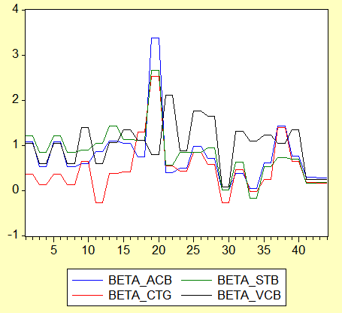
(source: finance.vietstock.vn/ACB)
ACB is one of the banks that completed the three pillars of Basel II early in accordance with Circular 41/2016/TT-NHNN and Circular 13/2018/TT-NHNN to improve risk management capacity and proactively internal ready to respond even in the most stressful situations of the market
Research questions:
Question 1: What are results of MEASUREMENT OF MACRO INFLUENCE ON BETA CAPM WITH VAR MODEL – A CASE STUDY OF OF ACB BANK?
Question 2: What are recommendations for risk policies?

2. Literature review

First, Gupta (2019) specified that Information system (IS) is important in almost all the functional areas of any bank i.e. HR, Marketing, Finance, etc. It also helps in risk management and cash management along with maintaining long run customer relationship.
Then, We summarize previous studies as follows:
Table 1 – Summary of previous studies
Authors | Year | Contents, results
Dai and Philippon | 2004 | analyzed the effect of budget deficit on interest rate, during the period 1965-2004 for United States. They concluded that there is a positive relation such that an increase in deficit can result in higher interest rate.
Conover, Jensen, Johnson | 1999 | firms react to this lower discount rate of their future cash flow and increasing income by adjusting their financial plans to generate higher sales and higher profits which leads to higher dividends. Johnson, Jensen and Conover in their empirical study from 1956-1995, considered index monthly returns for twenty developed markets and found that monetary expansion and stock returns had a positive relation for most of the countries. This result supports Blanchard’s theory regarding money supply effect on stock returns.
Suh | 2009 | conducted a time-series test on CAPM and FF3 for a specific estimation of the equity capital in a corporate investment decision-making perspective. The data was collected from a wide variety of stocks for over five years, conducted daily and monthly. The most consistent result of the study was the market risk premium. The results of the study show that the market risk premium, for individual stocks and portfolios, is significant in its results and the two models worked as complements. CAPM was generally better at estimating the large-growth portfolio returns and was not able to provide a reasonable estimate for the small-value portfolios
Balcilar et al. | 2016 | it is extremely difficult to ignore the existence of extreme risks because to uncertainty has several sources, including turbulent financial markets
Kassi et al | 2019 | show that the different measures of market risk have significant negative influences on the companies’ financial performance. The elasticities are greater following the degree of financial leverage compared with the book-to-market ratio and the gearing ratio. In most cases, the firm’s age, the cash holdings ratio, the firm’s size, the debt-to-assets ratio, and the tangibility ratio have positive effects on financial performance, whereas the debt-to-income ratio and the stock turnover hurt the performance of these non-financial companies. Therefore, decision-makers and managers should mitigate market risk through appropriate strategies of risk management, such as derivatives and insurance techniques
(source: author synthesis)

3. Methodology
Method and Data
This study mainly use combination of quantitativemethods and qualitative methods including synthesis, inductive and explanatory methods.
For quantitative analysis, the study is supported with VAR model with Eview.
Data is collected from reliable internet sources and websites.

Looking at descriptive statistics below, we see that:
- Std. Dev of GDp growth and Risk free rate Rf are lowest values
- Mean value of R is 0.10 and Rf is 0.047
Figure 1 - Descriptive statistics
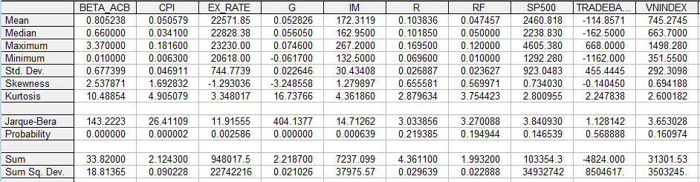
(source: author analysis with Eview)

4.Main results
4.1 Overall results
We see from charts that:
- First, ther is positive corr between beta and : VnIndex, exchange rate (chart 3, chart 5)
- Second, there is negative relation beteen beta and: R, Cpi, Rf (chart 2, chart 4, chart 8)
Chart 2 – CPI and beta

VCB | STB
(source: author analysis with Eview)

Chart 3 – VNIndex and Beta
VCB | STB
(source: author analysis with Eview)

Chart 4 – Rf and beta
VCB | STB
(source: author analysis with Eview)

Chart 5 – Ex rate and Beta
VCB | STB
(source: author analysis with Eview)

Chart 6 – G and beta
VCB | STB
(source: author analysis with Eview)

Chart 7 – IM and beta
VCB | STB
(source: author analysis with Eview)

Chart 8 – R and beta
VCB | STB
(source: author analysis with Eview)

4.2 VAR results
We follow below steps:
Step 1: Test unit root
Variable Beta ACB:
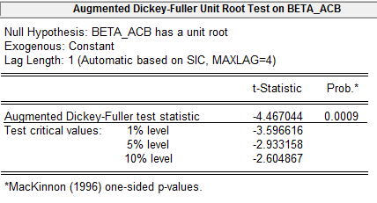
Variable CPI
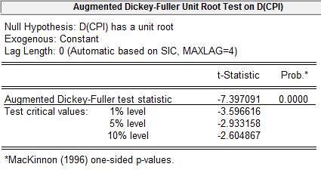
Variable G
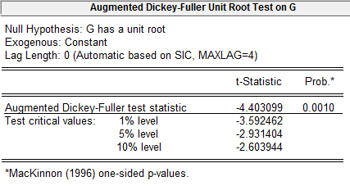
Variable IM
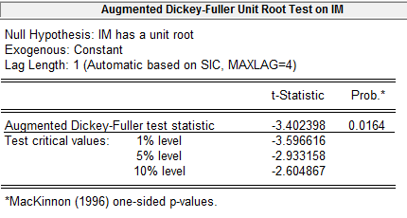
Variable R
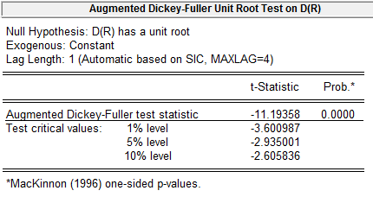
Variable Rf
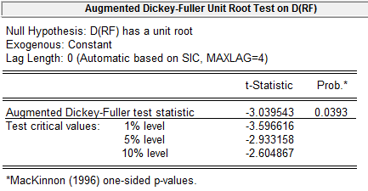
Variable Exchange rate
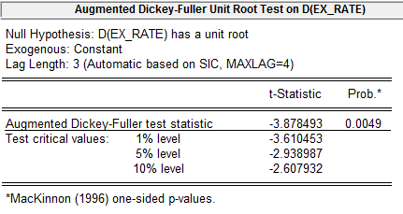
Variable SP500
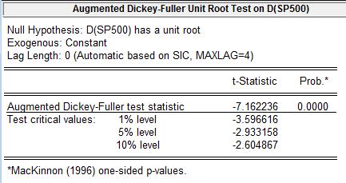
Variable Trade balance
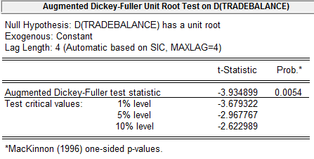
Variable VnIndex
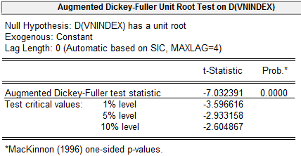
Next after testing unit root for all variables, we have VAR model following:
Beta_ACB D(CPI) G IM D(R) D(Rf) D(Ex_rate) D(SP500) D(Tradebalance) D(VNIndex)
Step 2:
Choose Lag length = 2 (minimum AIC)
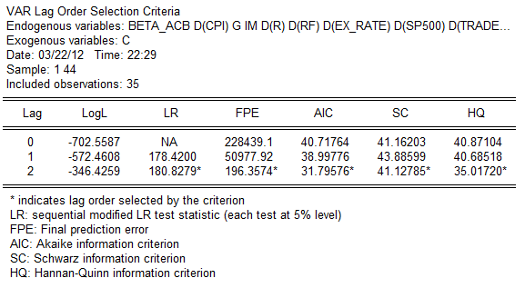
Choose Quick Estimate VAR
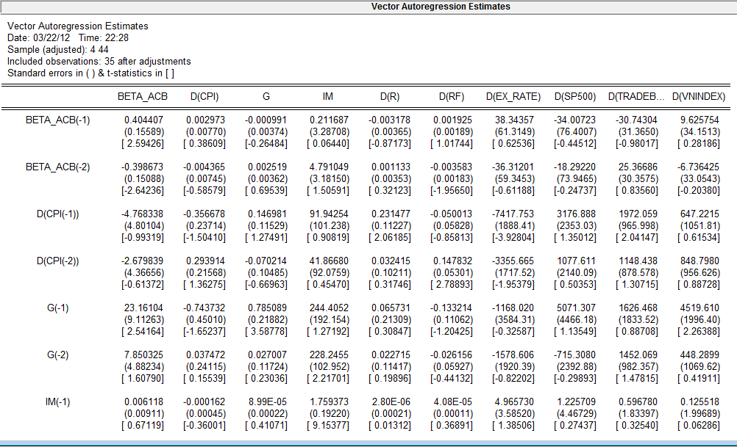

Step 3: Test model stability
AR Roots Graph
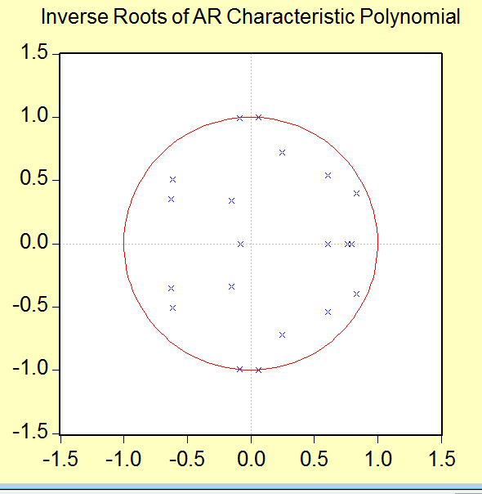
Step 4: Test residual
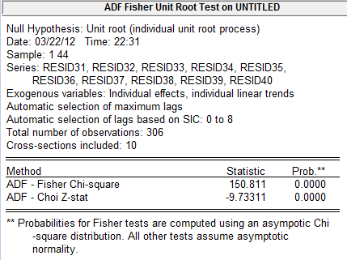
Step 5: Test Cholesky
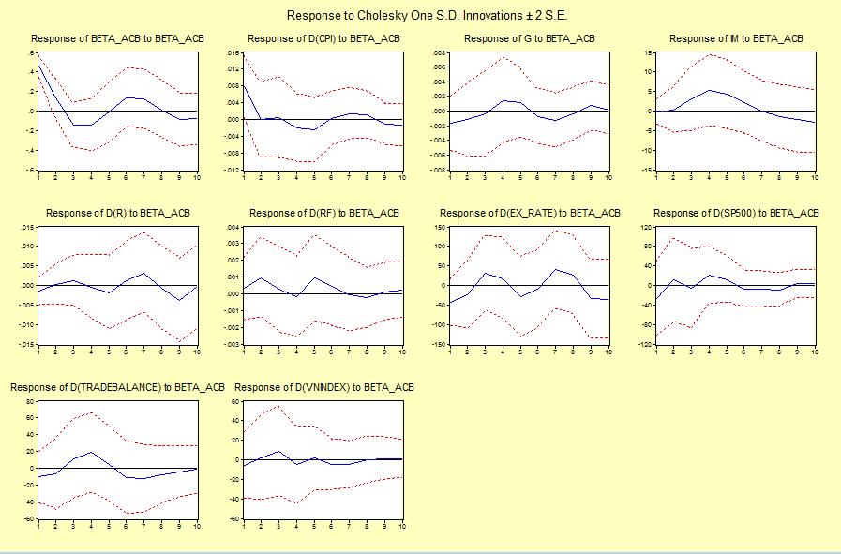

(source: author analysis with Eview)
Analysis:
- First, in medium term if CPI reduces then Beta ACB declines
- Second, in long term if lending rate declines then beta ACB will declines
- Third, in long term if exchange rate declines then beta ACB will decline
- Fourth, in long term if Vnindex stabel then beta ACB will be table
- Fifth, from AR root graph all results located in the circle, our model has no error.

4. Discussion and conclusion
- In above results of Cholesky impulse testing, we find out: First, in medium term if CPI reduces then Beta ACB declines
- Second, in long term if lending rate declines then beta ACB will declines
- Third, in long term if exchange rate declines then beta ACB will decline
- Fourth, in long term if Vnindex stabel then beta ACB will be table

Therefore, we would suggest that:
Ministry of Finance, State bank of Vietnam and relevant agencies need to control CPI (not increase too much) and also not increasing lending rate so much for beta ro reduce. Also we need to sablize Vnindex and exchange rate so that beta more stable.

Limitation of research
We can expand our research model for other industries and other markets.
Conflicts of interest
There is no conflict of itnerest

References
Bernanke, B. S. (1983). Irreversibility, uncertainty and cyclical investment. The Quarterly Journal of Economics, 98(1), 85– 106.
Balcilar, M., Demirer, R., Hammoudeh, S., Nguyen, D.K. (2016), Risk spillovers across the energy and carbon markets and hedging strategies for carbon risk. Energy Economics, 54, 159-172
Conover, C.M. and G.R. Jensen. and R. R. Johnson. (1999). Monetary Condition and International Investing, Financial Analysts Journal CFA Institute 55.4, 38-48
DT Tinh et al. (2021). Doing Business Research and Teaching Methodology for Undergraduate, Postgraduate and Doctoral Students-Case in Various Markets Including Vietnam, Elementary education Online 20 (1)
DVT Thuy, DTN Huy, VTK Anh, NN Thach, HT Hanh. (2021). Quality of education of ethnic minority communities in vietnam-problems and recommendations, Elementary Education Online, 20 (4)
Do Thu Huong, Dinh Tran Ngoc Huy, Nguyen Thi Hang ,Pham Thi Huyen Trang ,Duong Thi Ngu. (2021). Discussion on Case Teaching Method in a Risk Management Case Study with Econometric Model at Vietnam Listed Banks – Issues Of Economic Education for Students, Review of International Geographical Education, 11(5).
DTN Huy. (2015). The critical analysis of limited south asian corporate governance standards after financial crisis, International Journal for Quality Research 9 (4),
DTN Huy, DTN Hien. (2010). The backbone of European corporate governance standards after financial crisis, corporate scandals and manipulation, Economic and business review 12 (4)
D Thi Ngu, DT Huong, DTN Huy, PT Thanh, ES Dongul. (2021). Language teaching application to English students at master's grade levels on history and macroeconomic-banking management courses in universities and colleges, Journal of Language and Linguistic Studies 17 (3)
DT Tinh, NT Thuy, DT Ngoc Huy. (2021). Doing Business Research and Teaching Methodology for Undergraduate, Postgraduate and Doctoral Students-Case in Various Markets Including Vietnam, Elementary education Online 20 (1)
DTN Huy, NN Thach, NT Hoa, NT Dung. (2021). Using Internet Data for Evaluating Market Risk During Period 2011-2020-A Case of Eximbank in Vietnam in the Concept of Sustainable Development, Webology, 18
Ferreira, Marcio Lorencini, Michele Nascimento Jucá, and Ricardo Goulart Serra. (2020). The Effect of Ownership Structure on the Yield Spread of Corporate Bonds. Theoretical Economics Letters 10: 926.
Koroleva, E. & Kopeykin, M. (2022). Understanding of Macro Factors That Affect Yield of Government Bonds, Risks 2022, 10(8), 166; https://doi.org/10.3390/risks10080166
Kassi, D.F.; Rathnayake, D.N.; Louembe, P.A.; Ding, N. (2019). Market Risk and Financial Performance of Non-Financial Companies Listed on the Moroccan Stock Exchange. Risks, 7, 20. https://doi.org/10.3390/risks7010020
Laeven, L., & Tong, H. (2012). US monetary shocks and global stock prices. Journal of Financial Intermediation, 21(3), 530– 547.
NN Thach, HT Hanh, DTN Huy, QN Vu. (2021). Technology Quality Management of the industry 4.0 and Cybersecurity Risk Management on Current Banking Activities in Emerging Markets-the Case in Vietnam, International Journal for Quality Research 15 (3)
NT Hoang, DTN Huy. (2021). Determining factors for educating students for choosing to work for foreign units: Absence of self-efficacy , JETT 12 (2), 11-19
NT Hang, DTN Huy, DT Tinh, DT Huyen. (2021). Educating Students in History and Geography Subjects through Visiting Historical Sites to Develop Local Economy and Community Tourism Services in Thai Nguyen and Ha Giang, Revista geintec-gestao Inovacao E Tecnologias 11 (3), 1-12
NT Hoa, DTN Huy, T Van Trung. (2021). Implementation of students&#39;s scientific research policy at universal education institutions in Vietnam in today situation and solutions , Review of International Geographical Education Online 11 (10), 73-80
Nguyen Dinh Trung , Le Huong Hoa , Bui Thi Thu, Dinh Tran Ngoc Huy, Le Ngoc Nuong (2021). USING ENGLISH TO TEACH STUDENTS WITH SOCIAL SCIENCES MAJOR - VIA A CASE OF SOME VIETNAM NEWSPAPERS WITH THE UK, ITALIAN AND FRENCH APPROACHES and REGULATIONS ON PUBLISHING FAKE NEWS AND INTERNET CRIME, Journal of Language and Linguistic Studies, 17(3), 1711-1725
NT Hai, DTN Huy, NT Hoa, TD Thang. (2021). EDUCATIONAL PERSPECTIVES ON DIFFERENCES BETWEEN MANAGEMENT CASE STUDY AND ECONOMIC & FINANCE CASE STUDY TEACHING IN UNIVERSITIES , Design Engineering, 12022-12034
ND Trung, DTN Huy, TH Le, DT Huong, NT Hoa. (2021). ICT, AI, IOTs and technology applications in education-A case with accelerometer and internet learner gender prediction , Advances in Mechanics 9 (3), 1288-1296
Ogawa, E., & Luo. (2022). Macroeconomic effects of global policy and financial risks, Intl J of Fin.Economics, 2. https://doi.org/10.1002/ijfe.2681
PTH Trang, DTN Huy, NT Hoa, DT Huong, DT Ngu. (2021). Analysis of VI Lenin and Ho Chi Minh Views on the Youth Education Process , Review of International Geographical Education Online 11 (5), 4552-4559
PN Tram, DT Ngoc Huy. (2021). Educational, Political and Socio-Economic Development of Vietnam Based on Ho Chi Minh’s Ideology, Elementary Education Online 20 (1)
P Anh, DTN Huy, DM Phuc. (2021). Enhancing Database Strategies for Management Information System (Mis) and Bank Sustainability Under Macro Effects-A Case Study in Vietnam Listed Banks, Academy of Strategic Management Journal 20, 1-15
Soares, J.C., Limongi, R., Junior, J.H.D.S., Santos, W.S., Raasch, M., & Hoeckesfeld, L. (2022). Assessing the effects of COVID-19-related risk on online shopping behavior, Journal of Marketing Analytics, 2022 issue. Retrieved from: https://link.springer.com/article/10.1057/s41270-022-00156-9
Slaper et al. (2018). Industry Clusters and Regional Economic Performance: A Study Across U.S. Metropolitan Statistical Areas, Economic development quarterly, 2. https://doi.org/10.1177/0891242417752248
PM Dat, ND Mau, BTT Loan, DTN Huy. (2020). COMPARATIVE CHINA CORPORATE GOVERNANCE STANDARDS AFTER FINANCIAL CRISIS, CORPORATE SCANDALS AND MANIPULATION, Journal of security & sustainability issues 9 (3)
S Lin et al. (2022). Exploring the Relationship between Abusive Management, Self-Efficacy and Organizational Performance in the Context of Human–Machine Interaction Technology and Artificial Intelligence with the Effect of Ergonomics, Sustainability 14 (4)
Suh, D. (2009). Stock Returns , Risk Factor Loadings , and Model Predictions : A Test of the CAPM and the Fama-French 3-factor Model College of Business and Economics Economics Department of Economics
Thao, N., Anh, N., & An, P. (2019). Impact of corporate social responsibility on reputation, trust, loyalty of the customers in the banking sector – Evidence in Dalat city. Science & Technology Development Journal -Economics-Law and Management, 3(3), 220-235. https://doi.org/https://doi.org/10.32508/stdjelm.v3i3.562
TTB Hang, DTH Nhung, DTN Huy, NM Hung, MD Pham. (2020). Where Beta is going–case of Viet Nam hotel, airlines and tourism company groups after the low inflation period, Entrepreneurship and Sustainability Issues 7 (3),
TTH Ha, NB Khoa, DTN Huy, VK Nhan, DH Nhung, PT Anh, PK Duy. (2019). Modern corporate governance standards and role of auditing-cases in some Western european countries after financial crisis, corporate scandals and manipulation, International Journal of Entrepreneurship 23 (1S)
Torres et al. (2020). Visualizing Research on Industrial Clusters and Global Value Chains: A Bibliometric Analysis, Front. Psychol., 2020 issue. https://doi.org/10.3389/fpsyg.2020.01754
Van Tuan, P., Huy, D. T. N., & Duy, P. K. (2021). Impacts of Competitor Selection Strategy on Firm Risk-Case in Vietnam Investment and Finance Industry. Revista Geintec-Gestao Inovacao E Tecnologias, 11(3), 127-135.
VQ Nam, DTN Huy, NT Hang, TH Le, NTP Thanh. (2021). Internet of Things (IoTs) Effects and Building Effective Management Information System (MIS) in Vietnam Enterprises and Human-Computer Interaction Issues in Industry 4.0, Webology, 18
Z Wang, M Akhavan, MNI Kashkouli, MJC Opulencia, DTN Huy. (2022). Sustainable wastewater management from shale oil production wells: emerging opportunities and barriers, Applied Water Science 12 (7), 1-6
V Thanh Binh, D Tran Ngoc Huy, P Thi Bich Ngoc, P Thi Hong Nhung. (2021). Effective Medicine Treatment for Corona Patients at Home in COVID 19 Pandemic-and Roles of Nurses and Doctors for Heart Failures Treatment Attached, JPRI, 33
VQ Nam, DTN Huy, NT Dung. (2021). Suggested Risk Policies from Comparison of 2 Groups of Vietnam Banks-Previous SOE Banks and Private Banks During Post-Low Inflation Period 2015-2020, REVISTA GEINTEC-GESTAO INOVACAO E TECNOLOGIAS 11 (2), 531-546
VQ Nam, DTN Huy, NT Thuy, NT Hang, NT Hoa. (2021). Historical Sites and Architectures in Thai Nguyen City and Ha Giang Province in Vietnam-Sources for Tourism Development, NEW ARCH-INTERNATIONAL JOURNAL OF CONTEMPORARY ARCHITECTURE 8 (2), 342-352
VQ Nam, DT Tinh, DTN Huy, TH Le, LTT Huong. (2021). Internet of Things (IoT), Artificial Intelligence (AI) Applications for Various Sectors in Emerging Markets-and Risk Management Information System (RMIS) Issues, Design Engineering, 609-618
VQ Nam, DT NGOC HUY. (2021). Solutions to Promote Startup for the Youth in Minoritty and Moutainous Region of Thai Nguyen Province-Vietnam, Journal of Contemporary Issues in Business and Government 27 (3), 2113-2118

